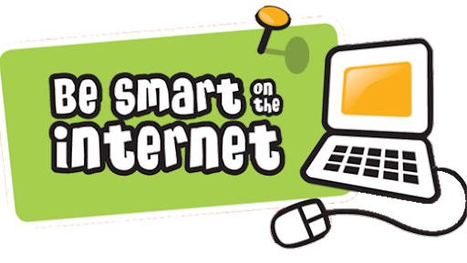
Online Safety Top tips!
Here are some top tips for you to think about though, specifically relating to younger children.
- It is recommended that young children use devices within sight and hearing (so without headphones) of an adult.
- Be mindful how older friends, siblings or relatives use the internet and devices around your child.
- Check age ratings of apps and games (PEGI ratings)
- Set up parental controls, filters and passwords, to reduce the risk of them seeing unsuitable material or purchasing downloads. More advice on this can be found here: https://www.internetmatters.org/parental-controls/
- Go on the internet with you child and join in playing their games! This is an ideal way to start conversations about safe internet usage. It is also makes it normal to use the devices with them, increasing the chance that they will talk more openly about their internet usage as they get older.
- Encourage them to use devices in a balanced way (use a mixture of games, research, learning etc) rather than becoming engrossed in one specific online activity.
- Draw up family rules around internet and device usage, including:
  - How much time will they spend on it? It is recommended that children have a maximum of 2 hours screen time a day (and 1 hour for 2-5 year olds)
  - What do they do if they come across something that worries them online? Most important message is to ask an adult for help.
  - Come up with a list of suitable games and activities that they can access. Setting up shortcuts to these would decrease the risk of finding unsuitable material.
  - Keep personal information private online, including names, passwords, age, school and address.
  - Always be kind online… just like in real life!
  - Talk about what to do if someone (a stranger) wants to talk to them online. Always come and ask a trusted adult for help.
  - When is it appropriate to a device? As a family are their times that should be screen free times (e.g. mealtimes). This is one we as adults can all reflect on and try to be a good role model!
- Our school E-safety rules are a good starting point for you to bring up rules for at home!
- We don’t want children to think the internet is all bad! Point out the good things about it… communicate with others, research interests, games, stories and so much more!
There is lots of useful information about online safety to be found on the following websites, which is worth a look:
Safer Internet https://www.saferinternet.org.uk/
NSPCC https://www.nspcc.org.uk/keeping-children-safe/online-safety/
SWGfL https://swgfl.org.uk/online-safety/
Common sense media https://www.saferinternet.org.uk/advice-centre/parents-and-carers

