Be Kind, Be Curious, Be You
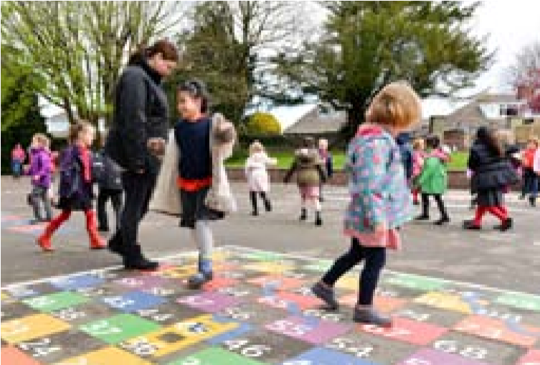
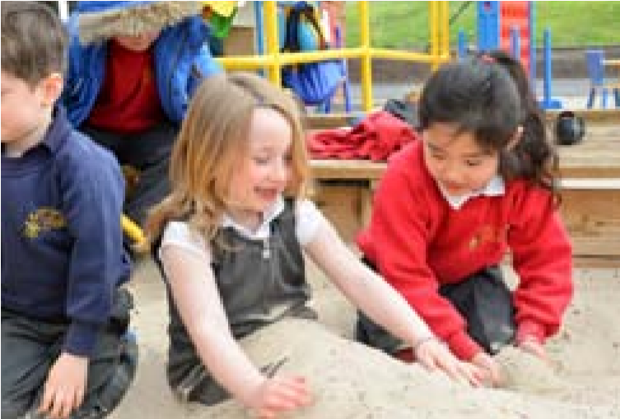
Prospectus 23/24

Welcome
Whether you are considering our school for your child or have a child about to start here, I would like to take this opportunity to welcome you. I hope that the information contained in this prospectus helps you to make the right choice for your child. Gemma Fricker, Headteacher.

What makes Henleaze Infant School such a special place?
At Henleaze Infant School we are committed to creating a happy, engaging environment where children feel valued as individuals and enjoy coming to school. We work hard to help children develop a love of learning and provide a rich and broad curriculum to ensure children are ready for their next stage in education. We have high expectations of children’s social and academic development. The children’s learning is well supported by our dedicated team of staff and governors, as well as through strong partnerships with parents.

We love our campus
We are fortunate to have a large site, where the children can enjoy outside spaces for learning and play with a Forest School area, pond and plenty of trees and grass.
We share a campus with Henleaze Junior School and Claremont Special School. The three schools have collaborated for a number of years so we can benefit from each others’ experience and expertise. For the children, this means the opportunity for pupils to work together, resulting in an enriched educational environment.

How to arrange a visit
If you would like to come and visit our school, you can find out about planned tour dates on the ‘about us’ tab of our school website (www.henleaze-inf.bristol.sch.uk).

Statement from Governors –

Amar Shah and Richard Lukes, co-Chairs

As Co-Chairs of Governors it is our pleasure to welcome you to our school. We are incredibly proud of the journey we have been on over the last few years, which sees our enjoyable and stimulating school in a strong and sustainable position. The majority of our governing board is made up of co-opted governors from our community and parent governors, but also includes our Headteacher, a staff governor and a local authority governor. Our role is to be a critical friend to the school, supporting where we can and challenging where appropriate to make sure all decisions are made in the best interests of the children in our collective care.
We are all dedicated to maintaining and improving the school to ensure consistency of learning across the age groups and to sustain the safe, caring and happy environment for all.

Our Values
At Henleaze Infant School a process of consultation involving pupils, parents and staff has established our vision of ‘Be Kind, Be Curious, Be you’. We fulfil this vision by engaging our whole community in understanding the importance of upholding our school values:
Kindness, Curiosity, Respect, Community

Kindness:

Our Values
In practice, this means:
- Being polite and friendly
- Playing together
- Sharing with one another
- Looking after someone if they are sad

Curiosity:
In practice, this means:
- Asking questions like the Curious Cat
- Celebrating our similarities and differences
- Showing interest in the world around us
- Enthusiasm to learn

Respect:
In practice, this means:
- Having good manners; listening to each other, being polite and taking turns
- Understanding that people might think or feel differently from us
- Looking after our school
- Understanding that each of us is special

Community:
In practice, this means:
Showing others that we all belong in our school
Working together (like the Teamwork Bee)
Making links with others outside of our school
Protecting our planet

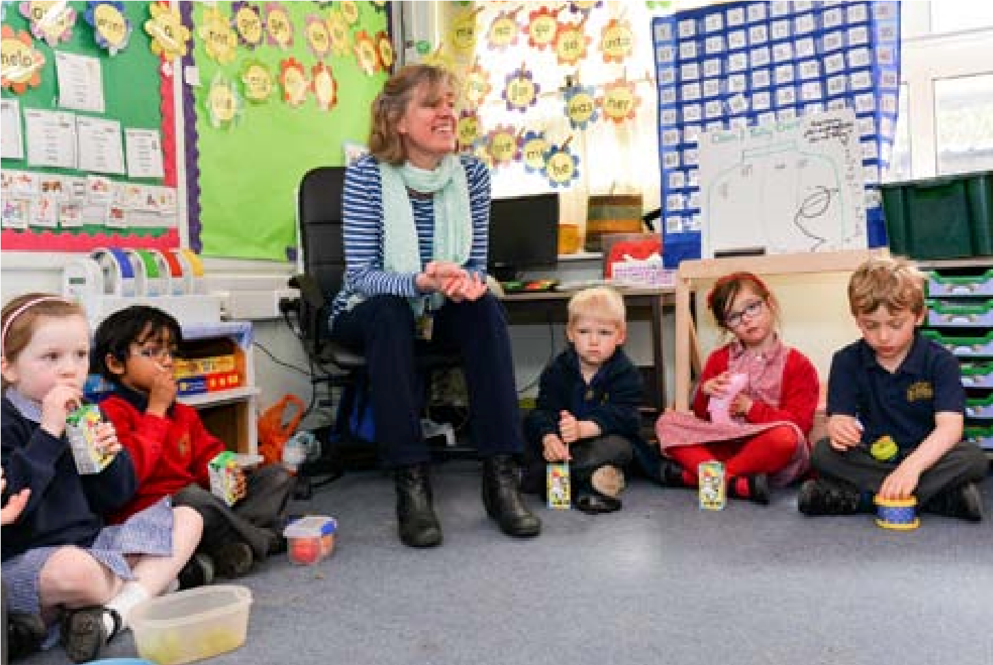
Our curriculum
The aim for our curriculum at Henleaze Infant School is to ensure that: Our children learn to celebrate their unique qualities and those in others and feel they belong to our school, our community, our city of Bristol, our country and the world. Our children are excited to learn, are curious and recognise the awe and wonder around them. Through the teaching of ELLI, children have gained the skills to learn effectively and the confidence needed to express their thoughts, challenges and opinions. They can think creatively to solve problems and meet new challenges with resilience. They have academic ambition and high aspirations for their futures. They have the foundations to grow into responsible, outward looking and generous global citizens, showing respect and empathy for others and our world. Our children have the knowledge, skills and emotional wellbeing to lead happy, healthy lives.

ELLI Learning Skills (Effective Lifelong Learning Inventory)
Henleaze Infant School strongly believe in a curriculum that enables children to learn the skills of effective life-long learners to support their attainment and progress. We develop these skills using ELLI. It uses seven animal characters to represent the seven identified characteristics of effective learners. Through the use of age-appropriate, child-friendly characters linked to a story, we give the children a shared language of learning and an understanding of the skills they need in order to become effective learners. Teaching and learning is woven throughout the curriculum and is a planned element in school assemblies and celebrations.
The seven skills are each represented by an animal, they are:
- The Curious Cat – Finding out, exploring and asking questions.
- The Teamwork Busy Bee – Working together.
- The Creative Unicorn – Being imaginative, finding creative solutions.
- The Wise, Plan-ahead Owl – Thinking strategically.
- The Linking Spider – Making Links with prior learning.
- The Adaptable Chameleon – Changing and adapting an approach to learning to improve.
- The Stickability Tortoise – Persevering no matter how hard things seem.
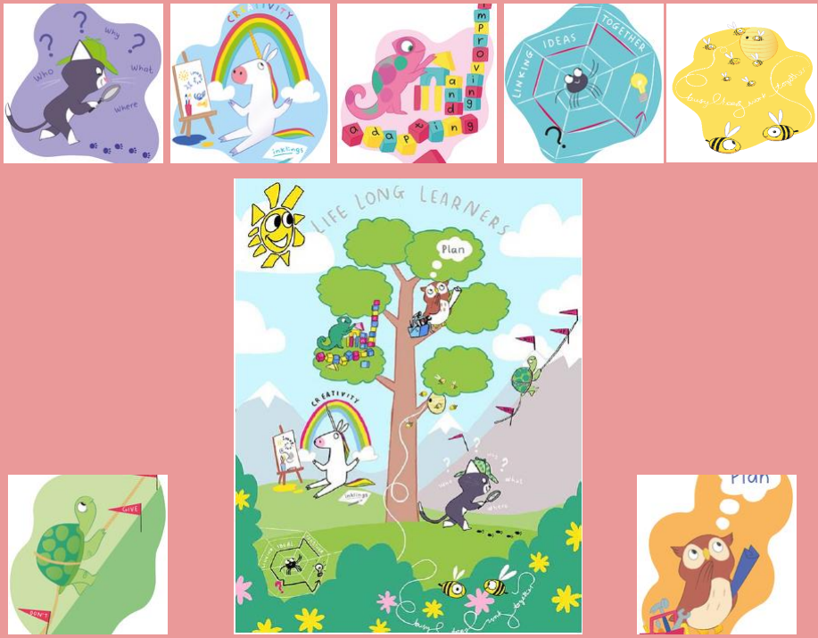

Reception Year: Induction to School
Our experience has shown us that children benefit from a staggered induction when they start their Reception year. This enables children to develop confidence as they build up their time and experience in school and for staff to build a strong relationship with each child and their family. We begin with stay and plays in the summer term before children start, then offer a home visit in early September followed by a planned transition timetable where children attend school in smaller groups, initially on a part-time basis. All children will be in school full time by the start of October.

Active, fun and healthy
A distinctive feature of the school is the wide variety of extra-curricular activities available. In addition to Breakfast and After School Club, outside specialists provide sports activities, Forest School and French, which children can enjoy if they wish.
We aim to help children understand how to live healthy lives by eating sensibly, exercising regularly and making healthy choices. To support this, school meals are freshly prepared on the premises with a hot meal or salad bar option available. The children also have fruit snacks in the morning and the afternoon.
We encourage active travel to school and take part in Sustrans initiatives to encourage children and families to ‘walk and wheel’ to school rather than drive.

Special Educational Needs
We believe that all children, including those identified as having special educational needs, have an entitlement to a broad and balanced academic and social curriculum, which is made accessible to them. We strive for all children to be fully included in all aspects of school life. At Henleaze Infant School we aim to identify needs as they arise and provide teaching and learning contexts which enable every child to achieve his or her full potential.

Transition to the Junior School
Children from Henleaze Infant School are guaranteed a place at the Junior School and our schools work together to ensure that this transition is successful. There are meetings for parents, Junior teachers visit the children in our school and meet with our teachers and the children have visits to the Junior school – for assemblies, playtimes and a taster day. Both schools work to ensure that all children are prepared for the next step of their educational journey.
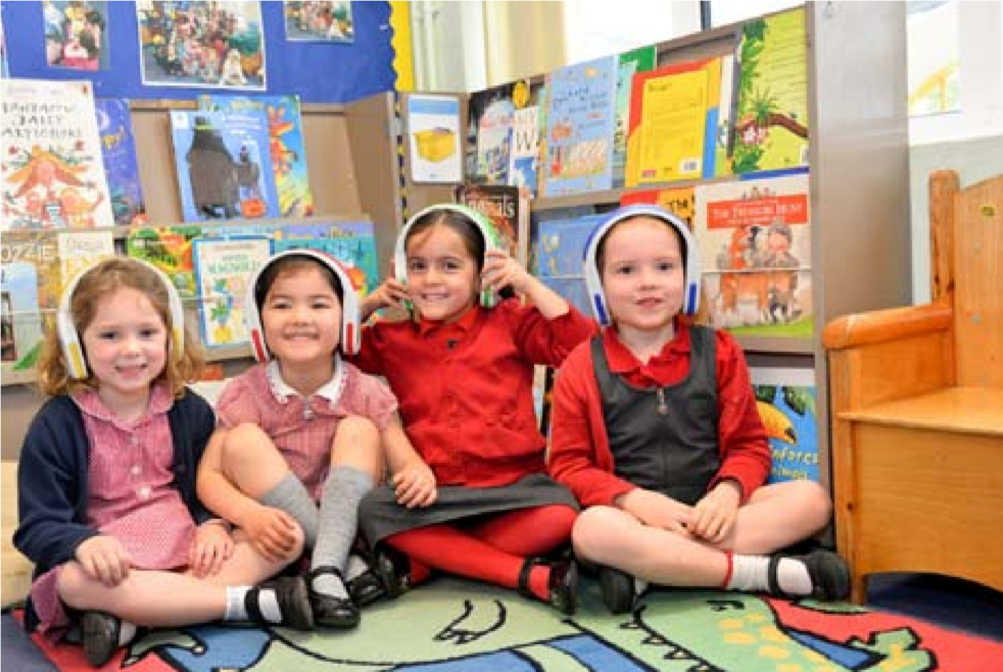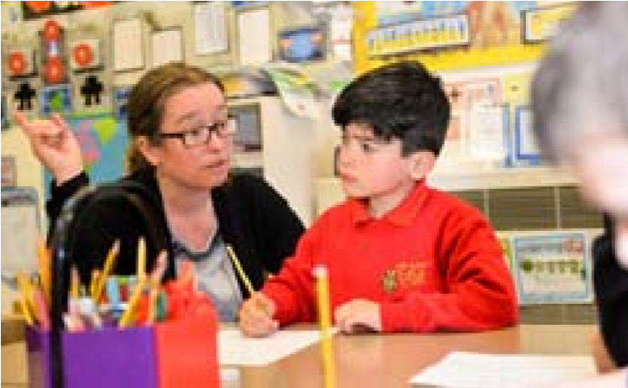
How parents and carers can get involved

We understand that learning is most successful when schools and families work together in partnership. We actively involve families in sharing their knowledge of their child as well as discovering more about their child’s time in school. We have developed a variety of digital solutions to support these valuable links.
As children progress through the school, parents are given the information needed to support their child in practising their reading skills, learning to spell some commonly used words, key number facts and helping with occasional wider curriculum home projects. We also provide useful guidance in supporting behaviour and well-being.

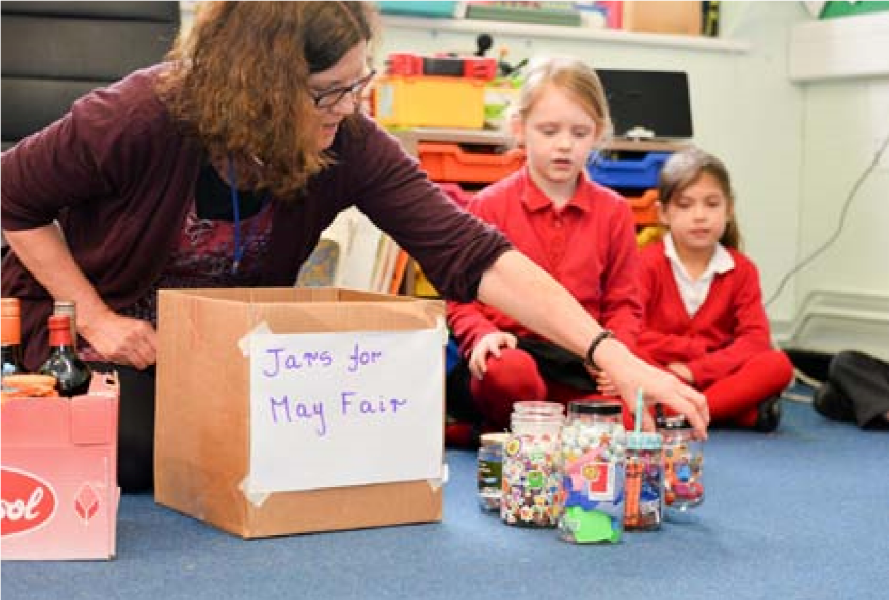
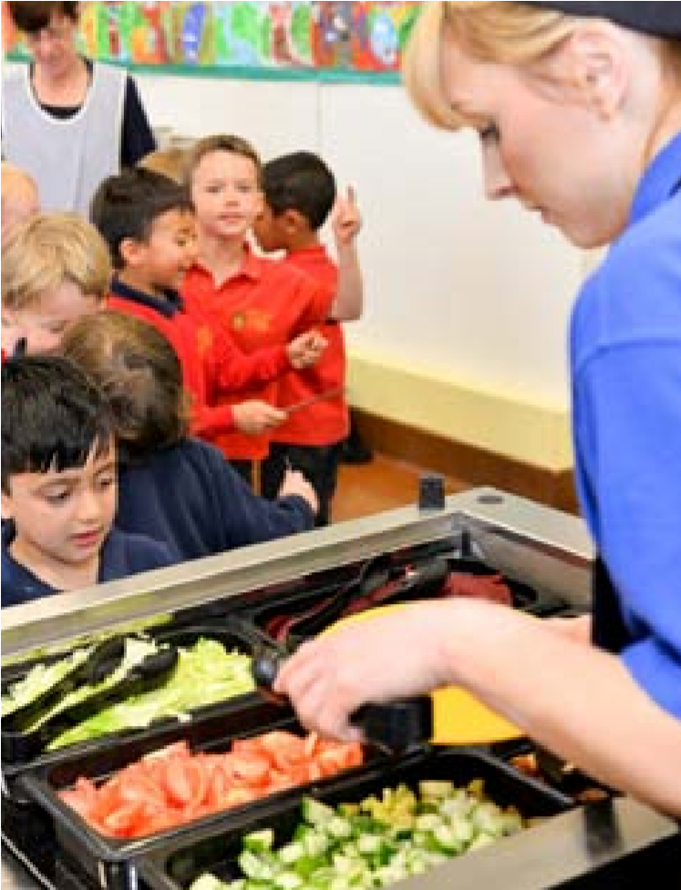

The school benefits hugely from parent volunteers who can either commit to regularly helping as ‘Reading Rangers’ or as one-off support for school trips or events.
In addition, there is the option to join FHIS (Friends of Henleaze Infant School) our Parent Teacher Association. This is an extremely supportive group of people who raise considerable funds for the school; in addition to arranging a variety of social events such as quiz nights for parents to attend. The biggest fund-raising events of the year are the Bonfire night firework display and the May Fair – fantastic events that bring together past and current pupils and their families and friends, together with the local community.

What the parents say
“We found the home visit really supportive as it prepared our daughter beautifully for her first day.”

“ The longer induction period gave my daughter extra time and attention that worked for us both.”

“The transition gave my son the time that he needed, in small steps to adapt to the new environment, routine, peers and teachers, enabling him to skip to school confidently”

“Mrs X’s feedback about our son was spot on-she clearly knows him so well, and we are thrilled with his progress this year. The strategies used in class sound perfect and he is clearly responding really well.

“ I am so happy with how my children have developed and grown during their time at Henleaze Infant School.

“The biggest change I have seen in X since starting school is her willingness to try again and keep practising if she is struggling.”

“All three of my children have settled quickly, made so many friends and love going to school every day.”

What the children say
I like school because you always Everyone is kind and gentle.
^{learn something new.}
I love my teacher because she is kind We get to learn and play all day.
and helps me understand my learning.
They do fun things at
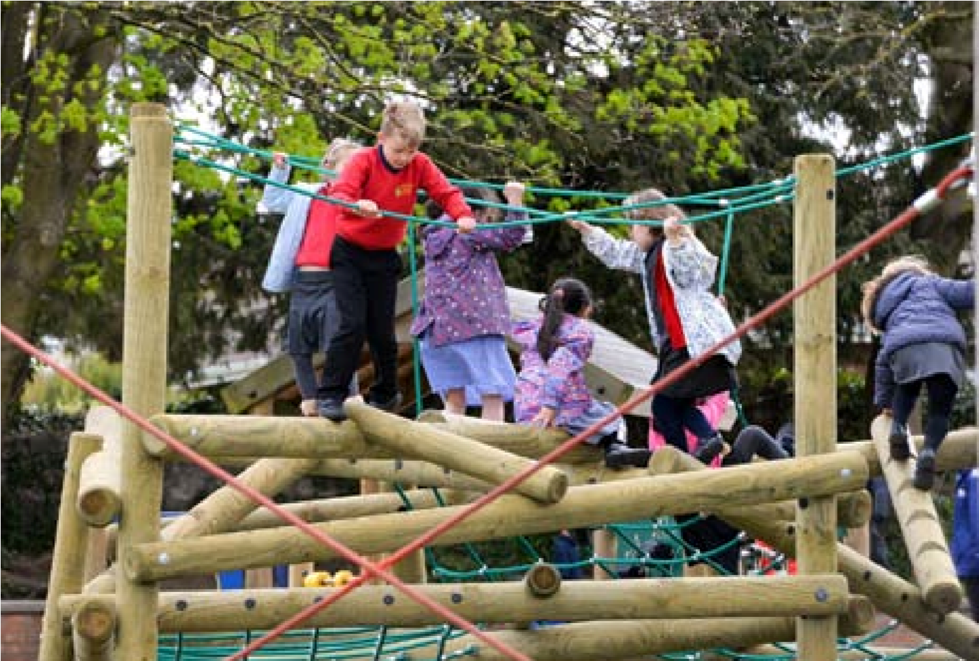
After School Club and the people are really nice.

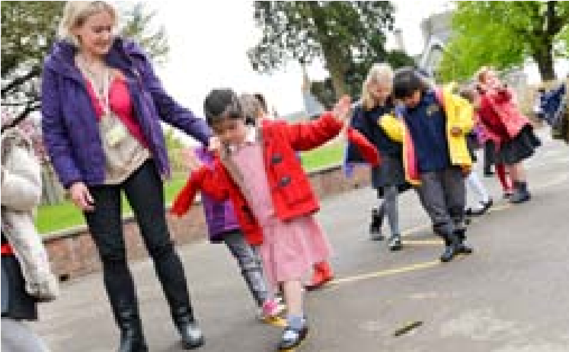
How to apply for a place
The school’s admissions process is managed by Bristol City Council Admissions department.
Advice on how to apply for a place for your child can be found on the Council’s website www.bristol.gov.uk
How to arrange a visit
We receive many requests to see the school, to manage this and prevent too much disruption for staff and children, we run a number of tours throughout the first terms of the school year. Dates are regularly updated on our website (www.henleaze-inf.bristol.sch.uk). In order to help us manage numbers, we ask that you book one slot per | family and note that the tours are not suitable for children. If you are applying for an in-year place i.e. not new Reception place, we can arrange visits for you and your child separately once a place has been confirmed.
Contact us

Henleaze Infant School
Park Grove, Bristol BS9 4LG.
Phone: 0117 377 2442
E-mail: Henleaze.i@bristol-schools.uk
Web: www.henleaze-inf.bristol.sch.uk

