'Be kind, be curious, be you'

5th January 2024 Bulletin

Headteacher update:
Welcome back and a happy new year to you all. Following two days of INSET training, it was wonderful to see the children back in school yesterday as like them, we thrive on the routine and buzz of day-to-day life in school.
This week classes have been settling in again, greeting friends, resetting expectations and have launched this term's PSHE (Personal, Social, Health and Emotional) theme 'Going for Goals) by reflecting on what they have achieved so far this school year and what they want to aim for. Across the school this term, we are also focusing on the school value of respect; thinking about what this means and what mutual respect looks like in practice through stories and examples. The concept of what a value is is quite challenging for young children to grasp. In my pupil conferencing last term, I found that children could talk about what makes our school a happy place, but did not know the four school values by name (they knew act kindly was a school rule). One child however, was able to say "a value is something that makes a person special" which I thought was a really great explanation in this context-thanks George! It would support us in school if you were able to reinforce the learning from school about respect (and our other values) through the day-to-day experiences you have together at home. Below is a photograph from our values display with what the children say illustrates respect:

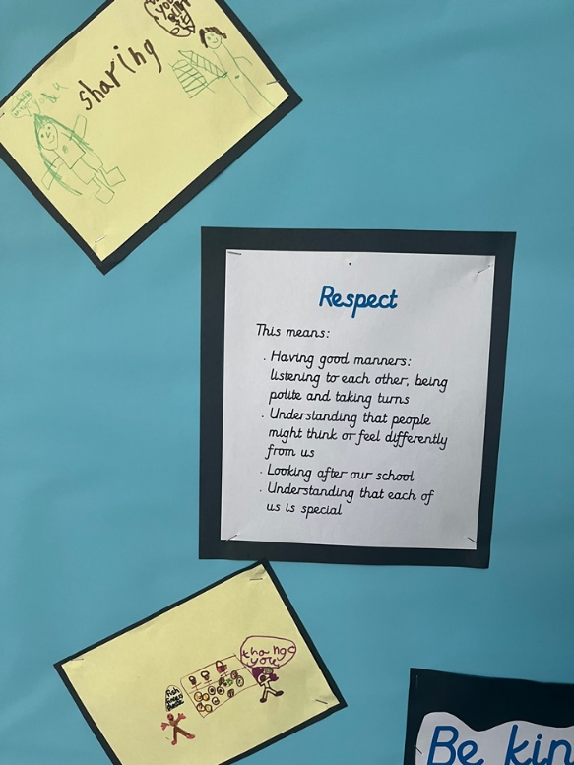

Have a good weekend.

Best wishes,

Gemma Fricker

Photos and information about what has been happening in classes, the learning plans as well as important messages from teachers are all found in the class blogs (click below)
Curriculum Update: Online Safety

In Term 2, we hosted an online safety evening alongside the juniors. For parents that weren't able to attend, and indeed those that want a recap of the session, we are going to be sharing a series of videos and content from our guest speaker Alan Mackensie. We will be sending a different video each week (attached alongside the newsletter) as well as useful links shared by Alan to relevant websites talked about in the videos. Each video is between 5 and 13 minutes long so hopefully not too much time to spare, especially for such an important area. One of the key messages I took from Alan was how valuable it is to get children into the habit of discussing their technology usage from an early age when they are open to talking about it. We therefore hope that the information in these videos will help with this.

Emma Ross
Computing Lead

Important Messages:

Reminder – 15th January 2024 closing date for new Reception School Applications for September 2024
Please remind parents and carers the closing date to make a new Reception year school application for September 2024 is fast approaching.
For families living in Bristol, our preferred method of application is online at Apply for a new reception primary place (bristol.gov.uk) It is quick and easy to apply, without the risk of the application form being lost in the post.
Families can also apply using a paper application form available to download online at Bristol Local Authority common application form for Reception year group admissions in September 2023
Please encourage completed application forms to be sent to School Admissions by email at school.admissions@bristol.gov.uk by the closing date.

